Geometry: Unit 4, Lesson 1

- Given the written description: “Move 2 units down.”, what is the algebraic description?

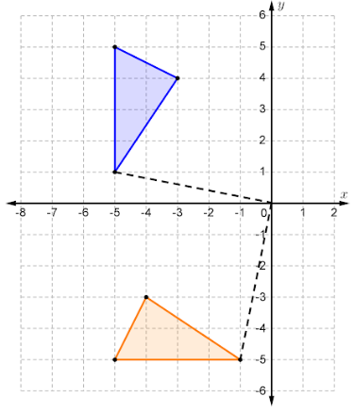

- What kind of transformation was performed on the upper triangle to map it to the lower triangle?

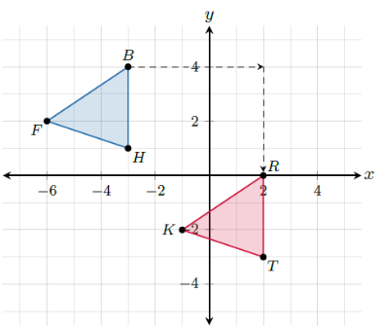
- Triangles $FBH$ and $KRT$ are shown on the coordinate grid. To map $∆FBH$ onto $∆KRT$, what do you have to do to $∆FBH$?

